Final Submission

Name:Aaysha Begam A

Emp Id:761155

Steps To Run Angular

1. Type this command in node.js ng serve

2. if any port error is displayed, then change port number by

ng serve –port=9990(You can give any port number)

3.It give “compiled successfully”

Here I give screenshot of angular run commands

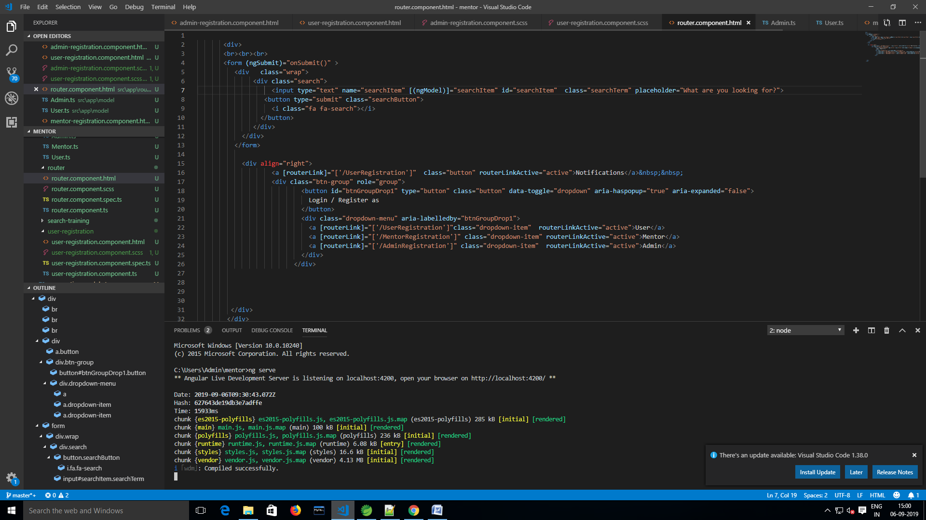

Git Hub Link <https://github.com/AayshaBegamAbubakar/UxPhase2.git>

Home Page:

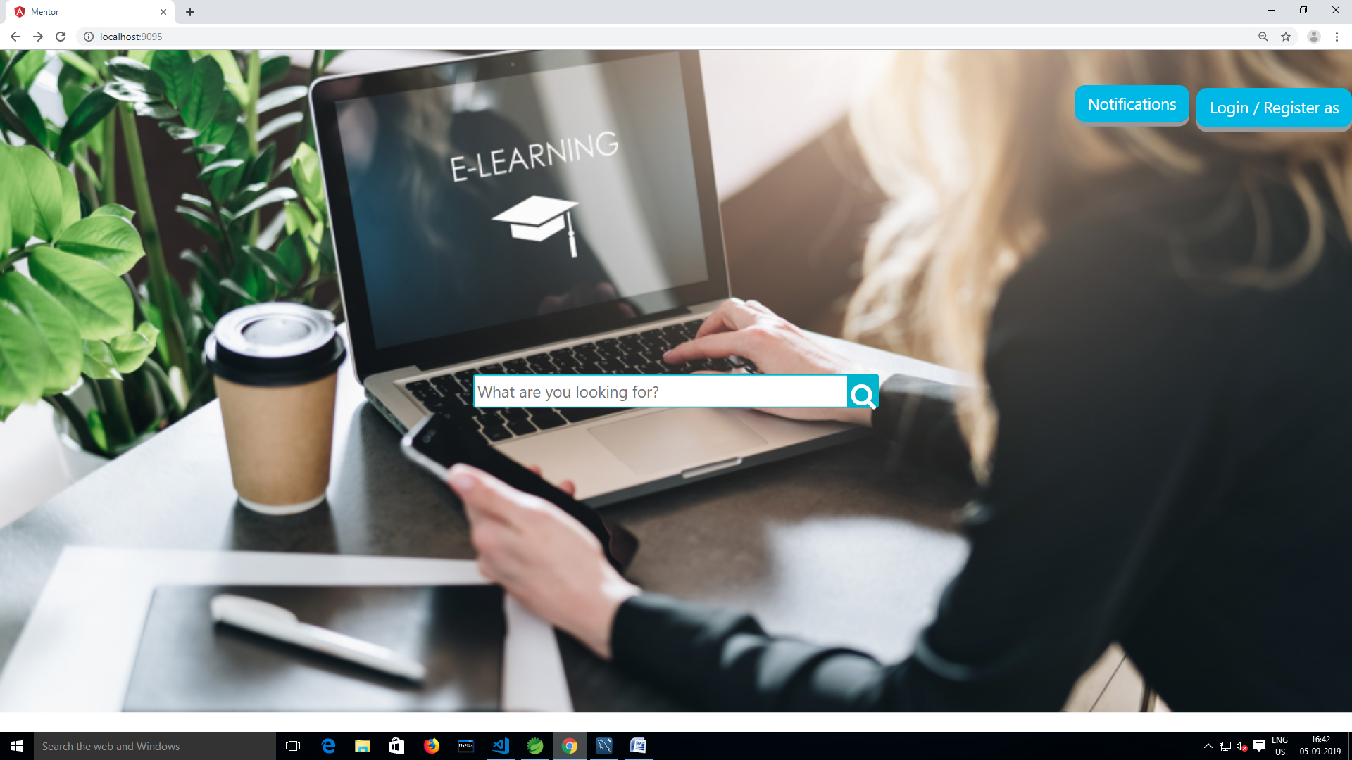

After Click Login/Register As Choose User,Admin,Mentor

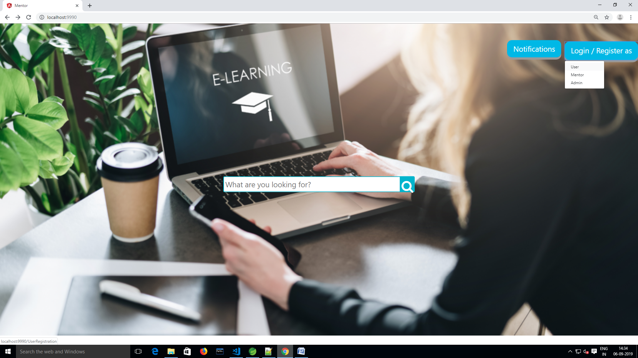

Mentor Sign Up Page:

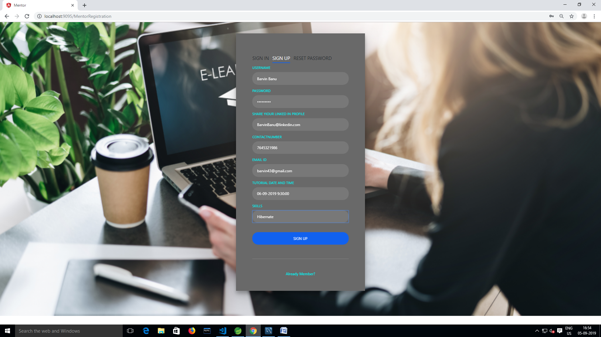

After Sign Up Mentor Details Saved in Database

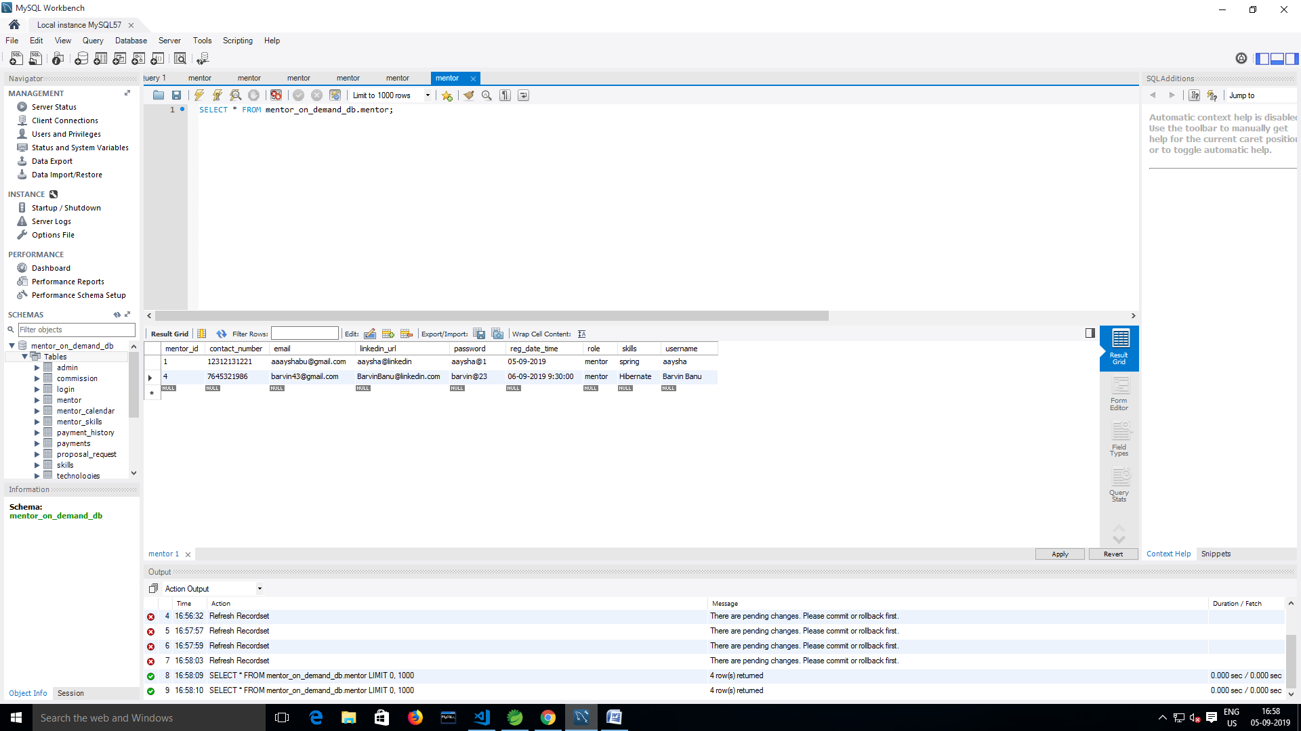

User Sign Up Page

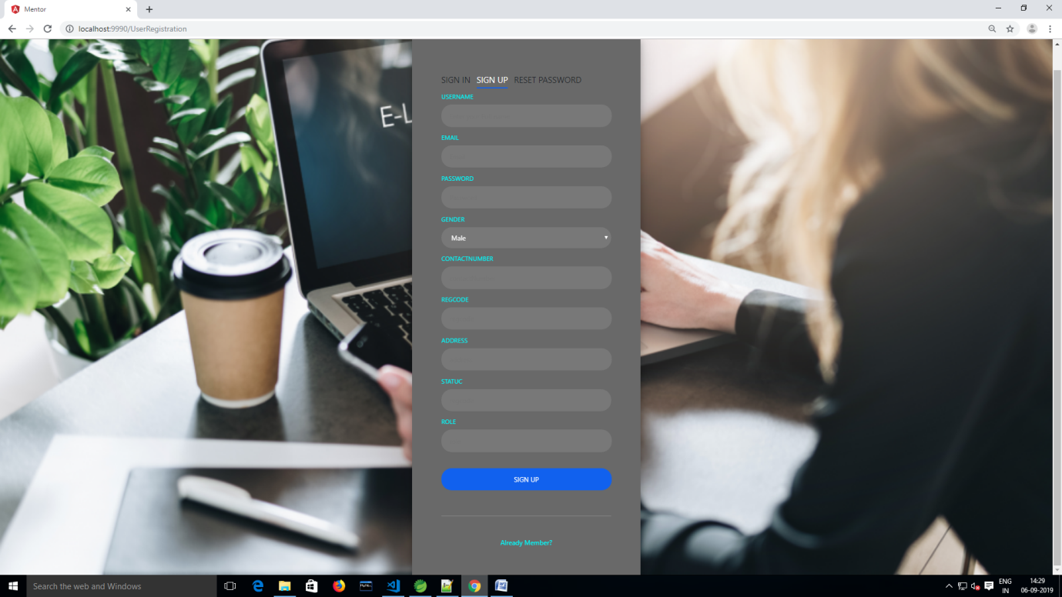

User Sign In Page

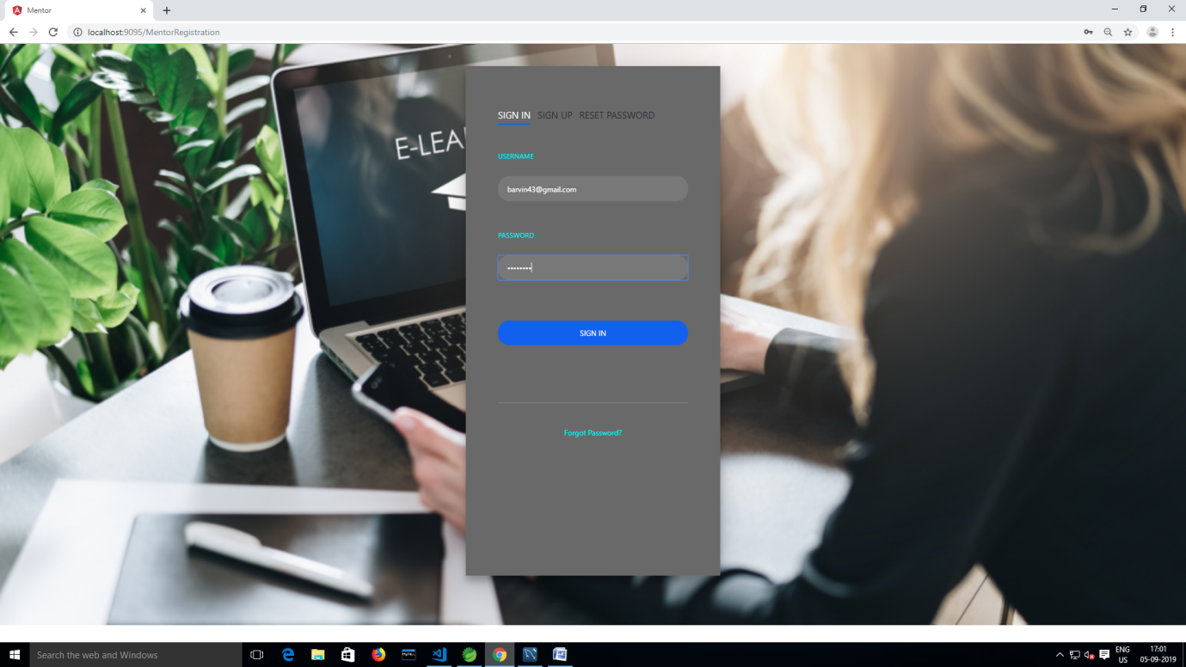

Any User Search “Spring” Related Training in Search Button

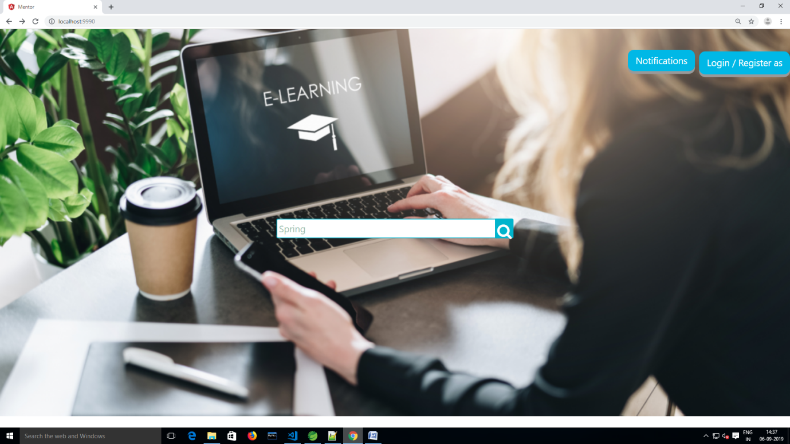

Results For Search “Spring” Related Training

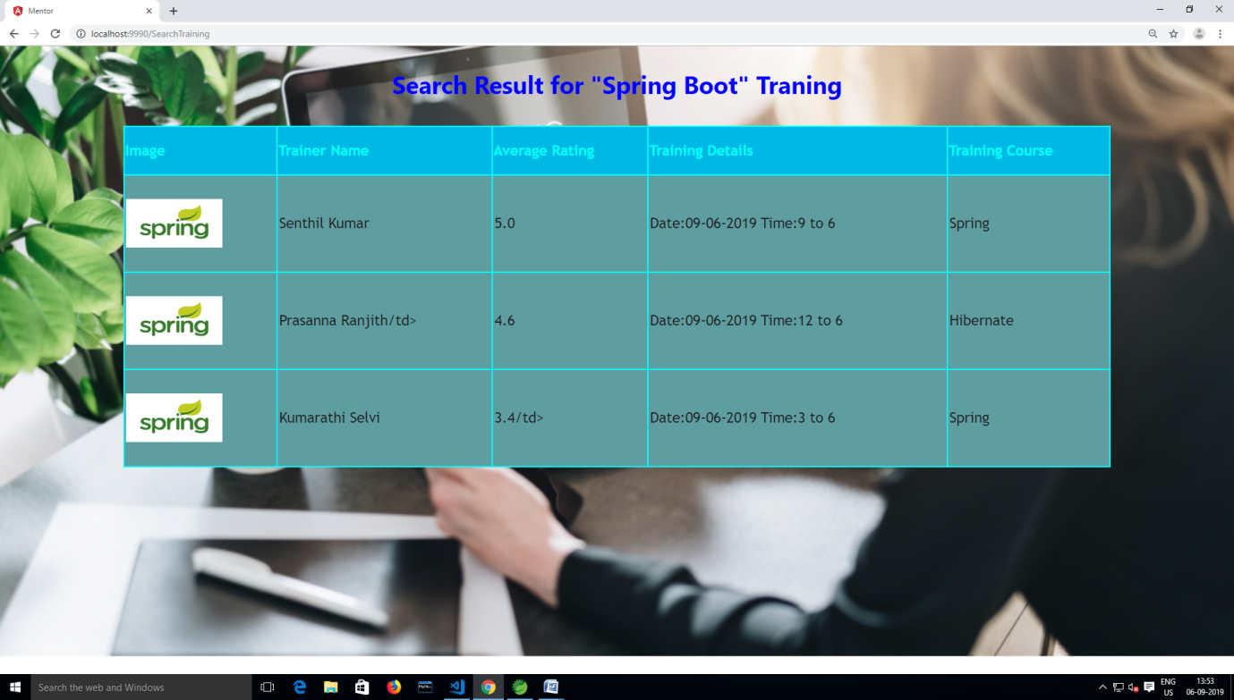

Admin Sign Up Page

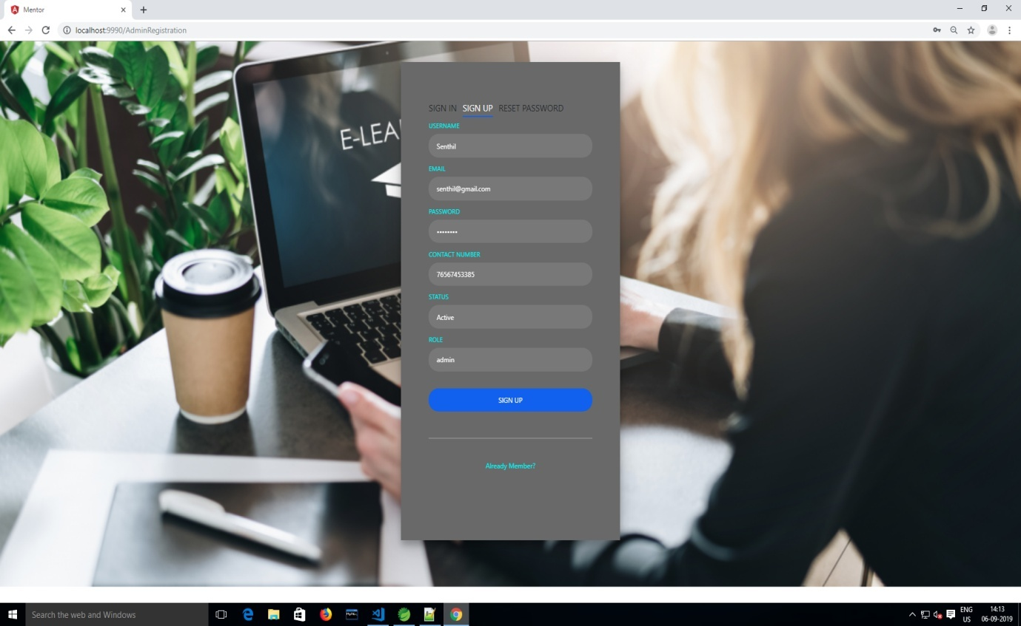

Admin Sign In Page

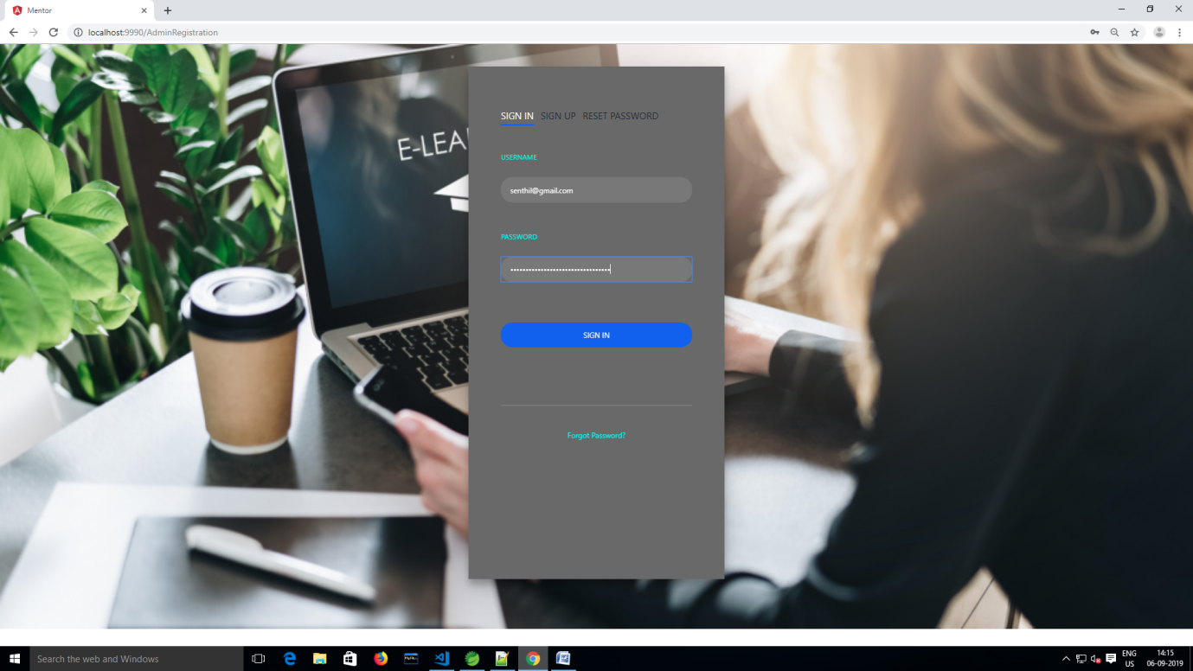

Payment Details

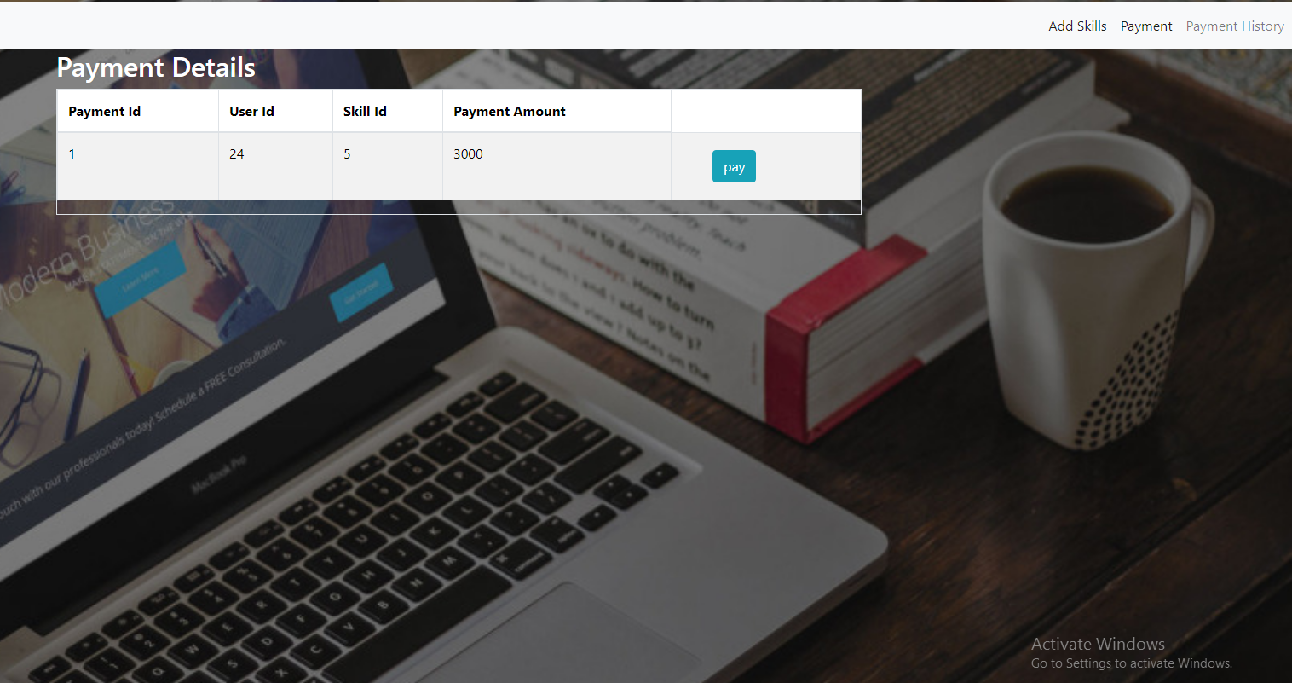

Add SkillS Button Function

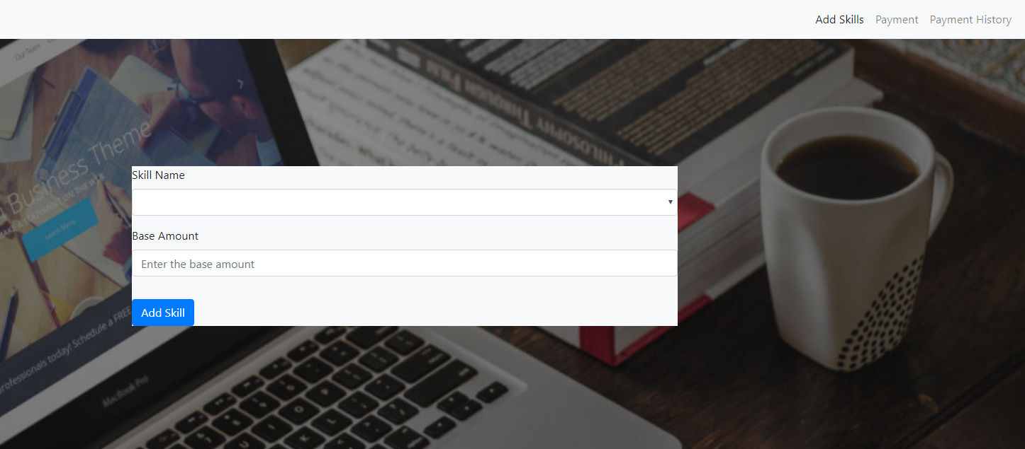

Payment Slot

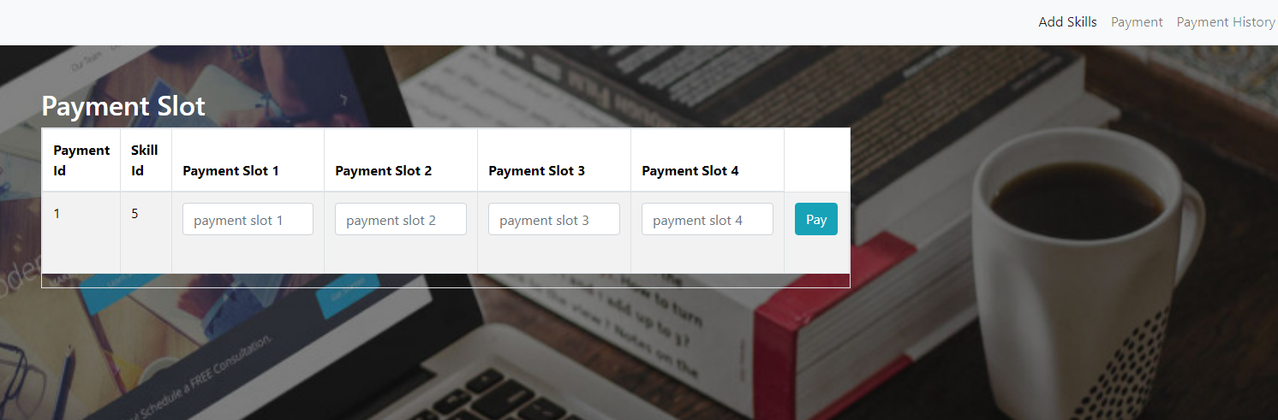

Add Skill

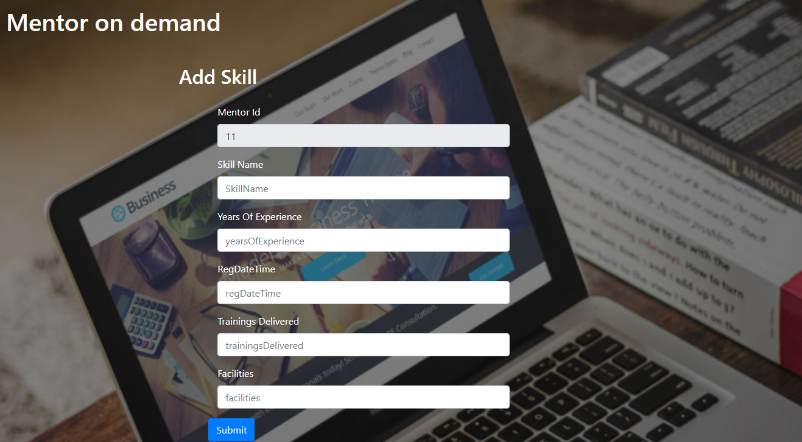

Tranings Details

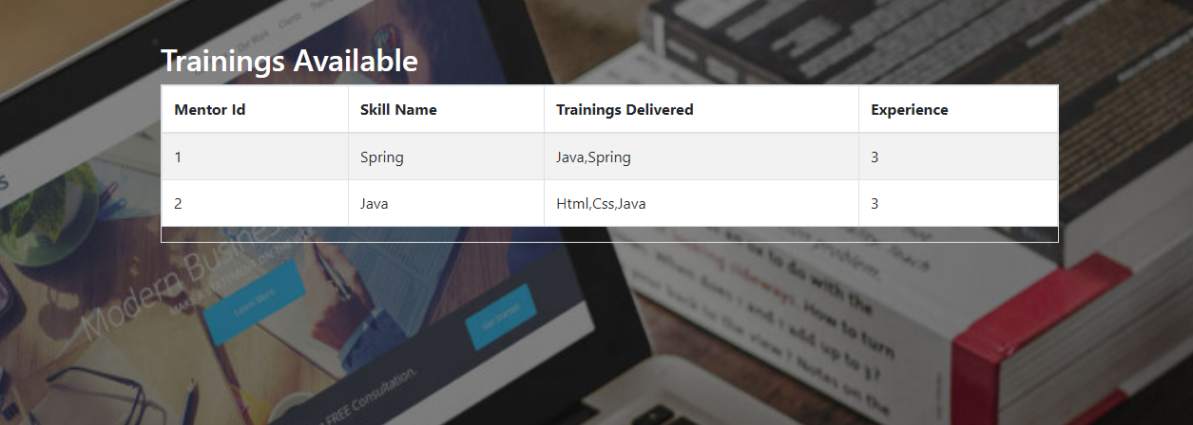

Steps To run Postman

1. Give url eg: <http://localhost:8254/api/mentor/register> in postman

2.Select method eg:post

3.Choose Body radio button in which select “ raw “

4. Then choose “json “

5.in that request body give data

Eg: {

"commissionPercentage":7.95

}

6.Click Send

7.result will be displayed “response body”

Postman ScreenShots

Mentor Controller

1.Insert Mentor Register Details <http://localhost:8254/api/mentor/register> method: post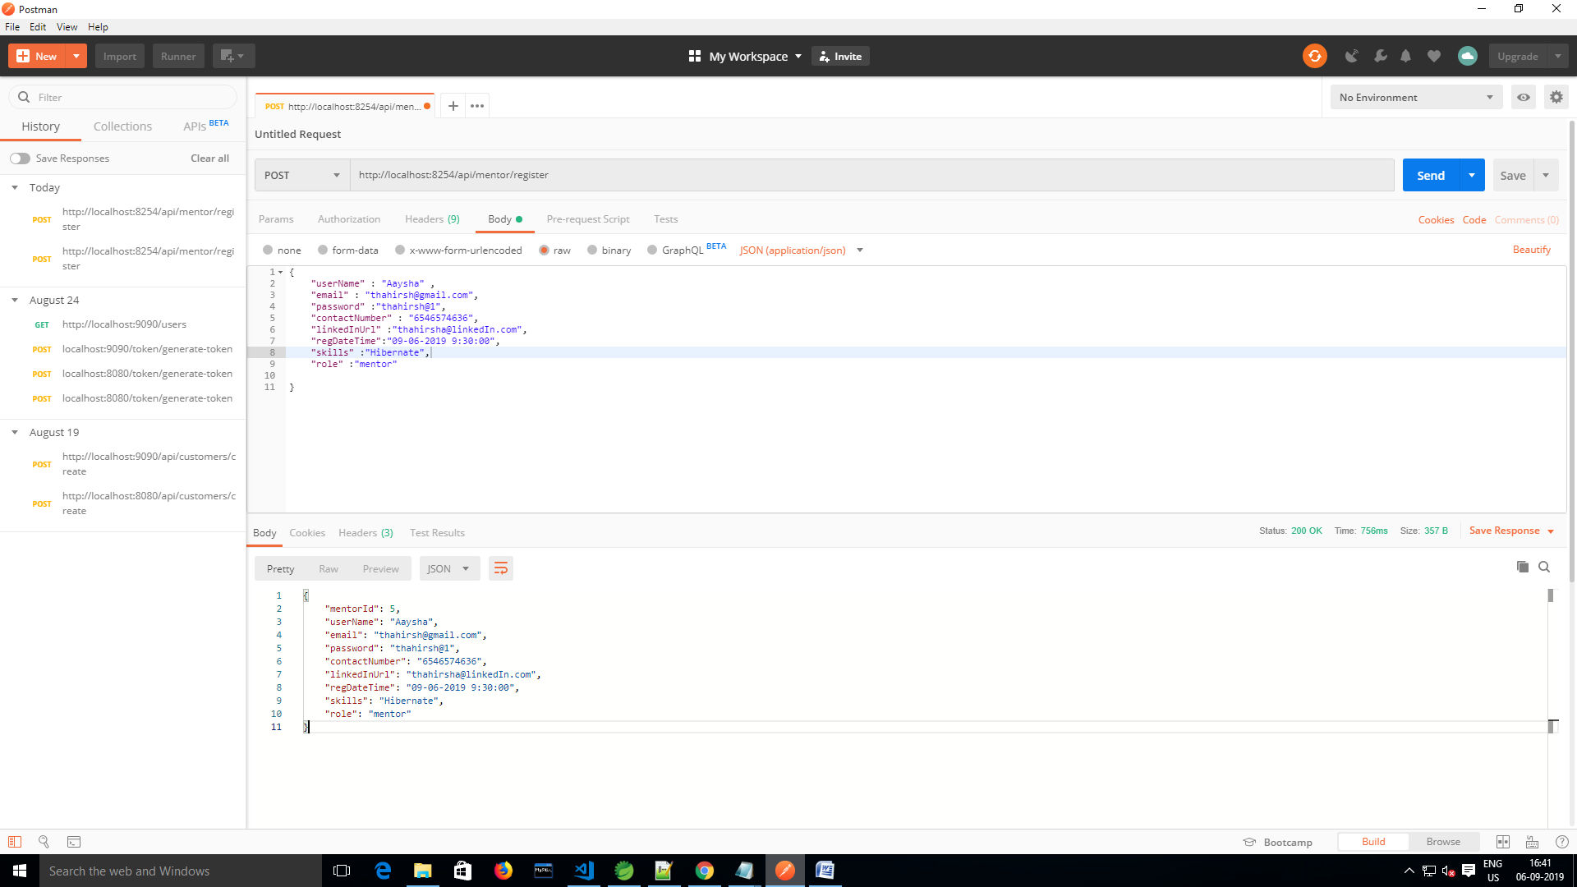

2.Delete Mentor by MentorId <http://localhost:8254/api/mentor/deleteSkill> methos:delete

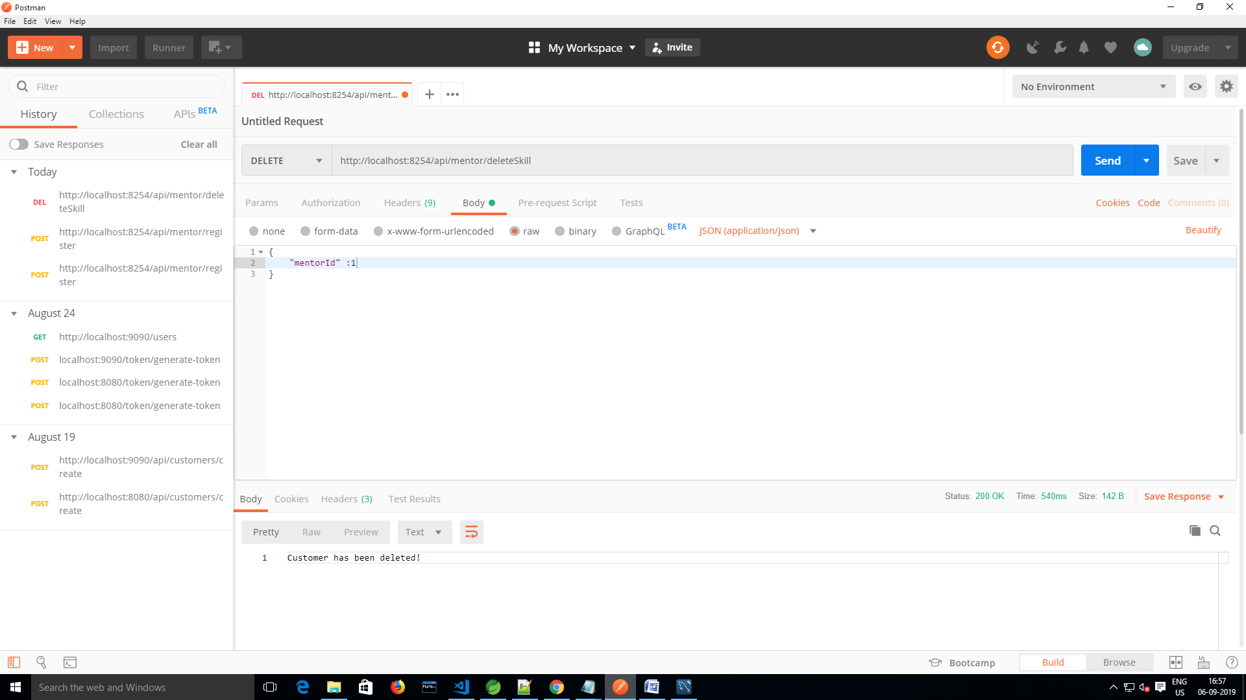

3.Add Skills to MentorSkill table <http://localhost:8254/api/mentor/addSkill> method:post

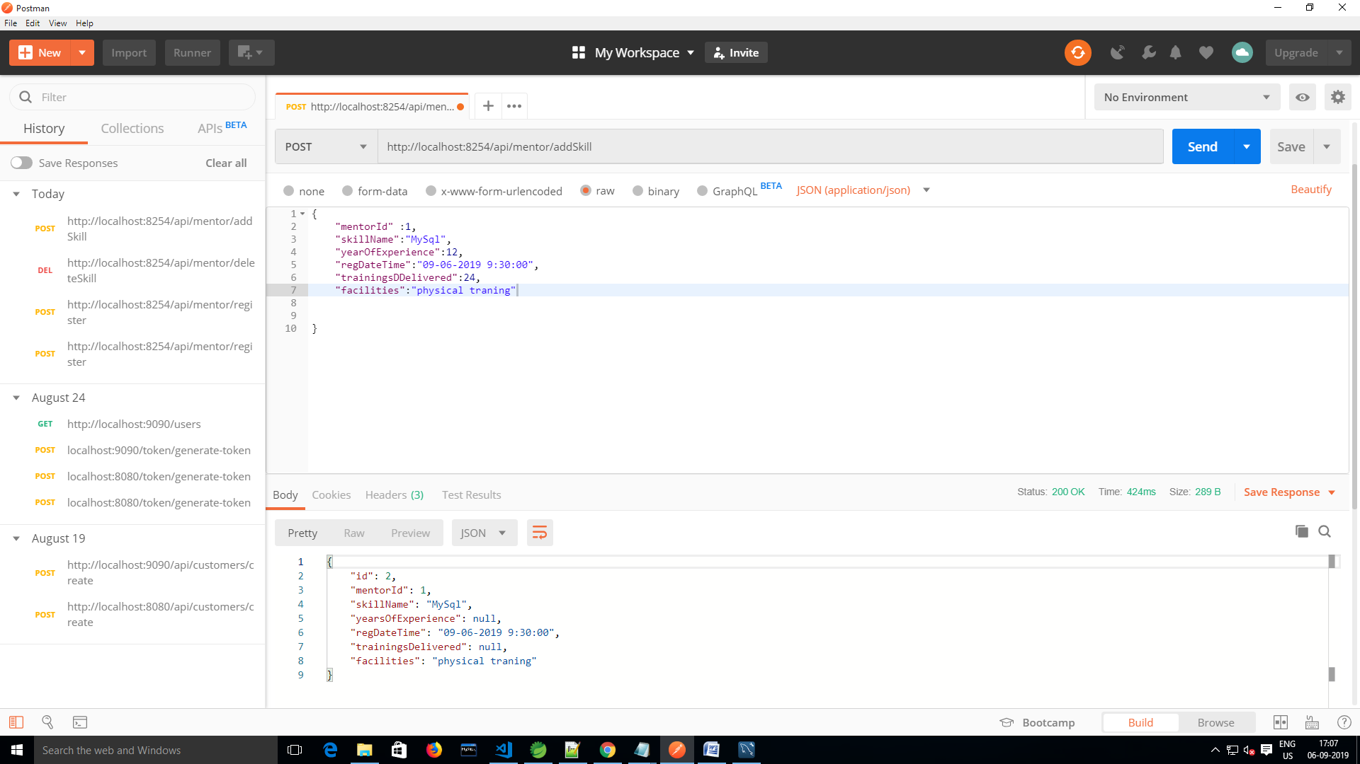

T**rainin**g Controller

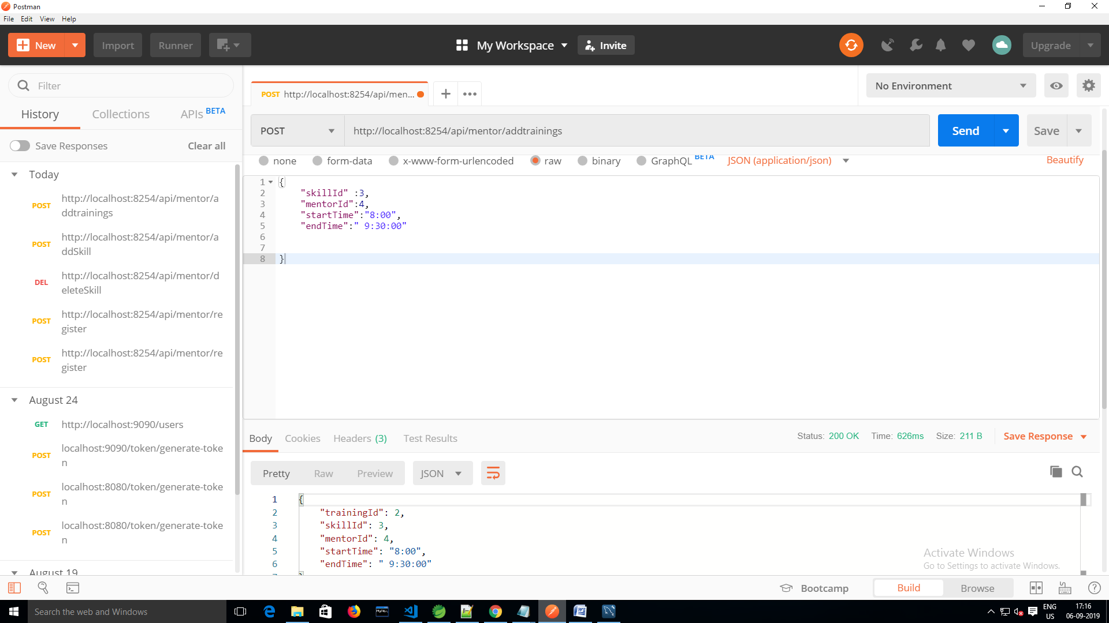

AdminController

1.Insert Amin details <http://localhost:8254/api/adminDetails> method:post

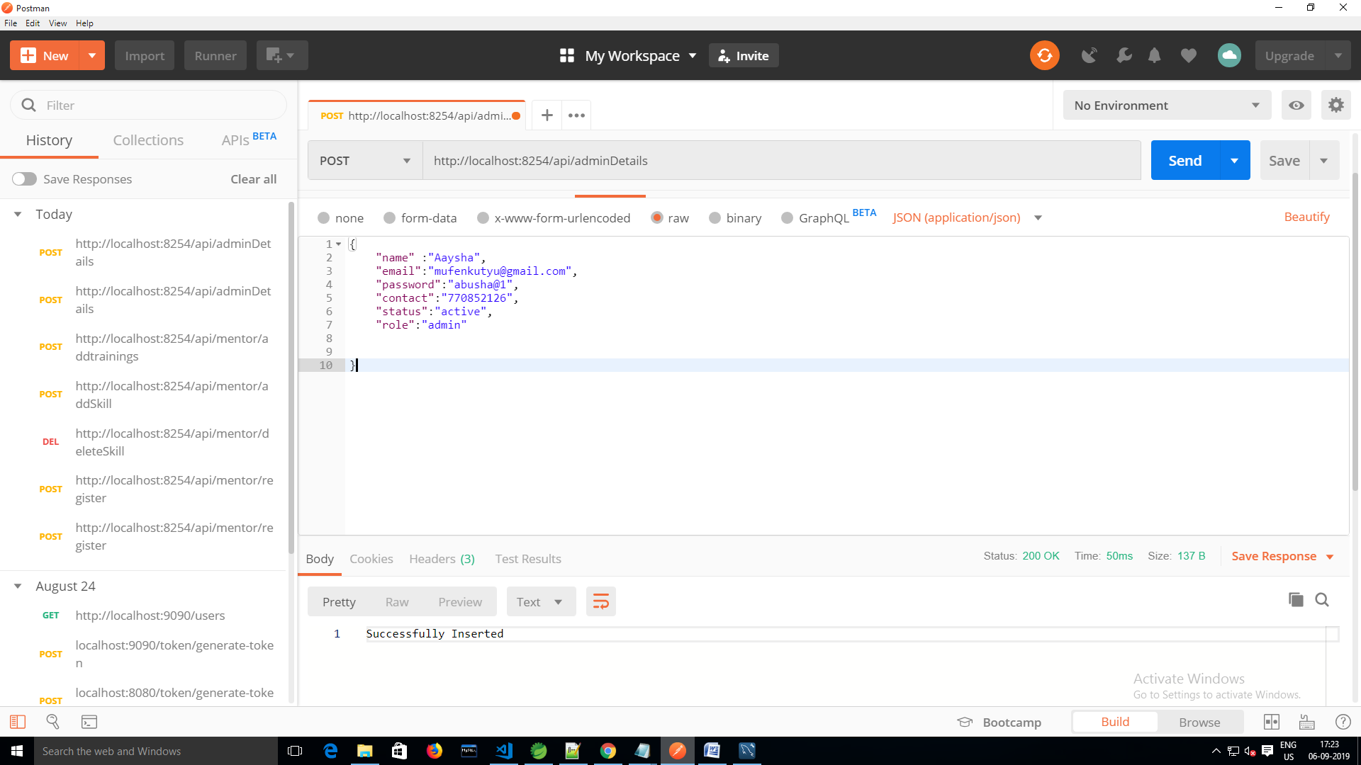

2.Update Commision Percentage <http://localhost:8254/api/UpdateCommission> method:post

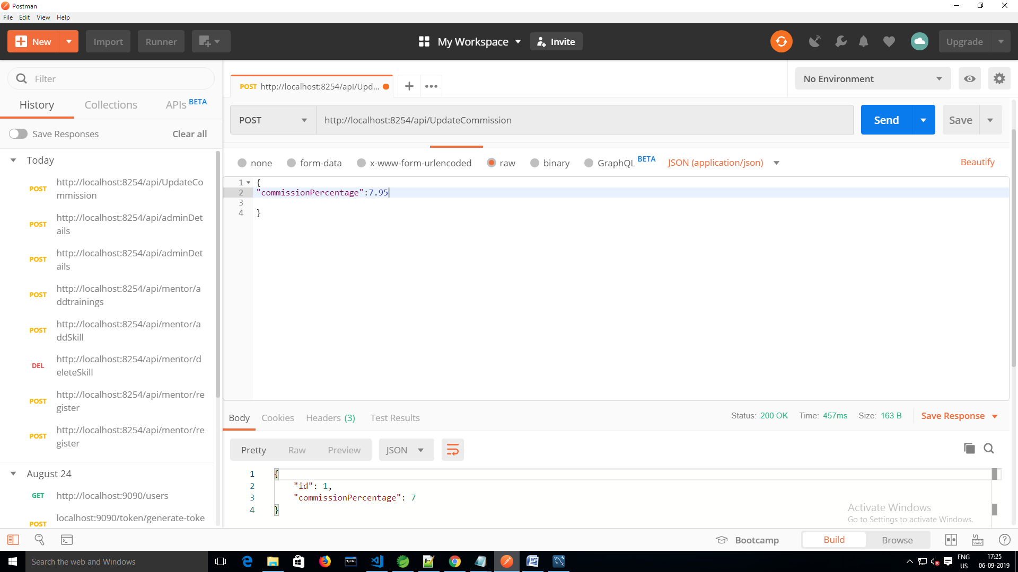

Git Hub Link : https://github.com/AayshaBegamAbubakar/mentor_on_demand_final.git